**Project ASP.NET**

**SecondZone.com**

**Name : Evan Afif Saputra**

**Ugi Ispoyo Widodo**

**Faculty : Emma Yulianti, ST. MM**

**Semester : 3**

**Quarter : 6**

**Class : 3SC4**

**Gedung Pascasarjana Lt. 3 Fakultas Teknik Universitas Indonesia**

**Kampus Baru UI Depok 16424**

**PROJECT ON**

**SecondZone.com**

Developed By

Name : Evan Afif Saputra

Ugi Ispoyo Widodo

Reg. No : 1410010066

**NIIT**

**SECONDZONE.com**

**Batch Code :**

**Start Date :** January 12th 2016

**End Date :** January 20th 2016

**Name of Coordinator :** Emma Yulianti, S.T, MM

**Name of Developer :** Evan Afif Saputra Saputra

Ugi Ispoyo Widodo

**Date of Submission :** January 21th 2016

**NIIT**

**CERTIFICATE**

This is certify that this report, titled SecondZone.com, embodies the original work done by **Evan Afif Saputra** and **Ugi Ispoyo Widodo** in partial fulfillment of their course requirement at NIIT

Coordinator:

Emma Yulianti, S.T, MM

**ACKNOWLEDGEMENT**

The Project presentation opportunity we have with CCIT-FTUI is a great chance for learning and professional development. Therefore, we consider ourselves very lucky as we are provided with an opportunity to be a part of it. We are also grateful for having a change to meet so many wonderful people and professionals who led us through this project period.

Bearing in mind, we would like to express our deepest gratitude and special thanks to Ms. Emma Yulianti of CCIT-FTUI faculty who is spite of being extraordinarily busy with her duties, took time out to hear, guide and keep us on the correct path and allowing us to carry out our project until completion.

Our Project assignment won’t be as good as it is now without any help, feedback and suggestion that were given to us by our friends within the campus. So, we would also like to say thank you to all of them. We will strive to use gained skills and knowledge in the best possible way, and we will continue to work on the improvements, in order to attain desired carrer objective.

**SYSTEM ANALYSIS**

SecondZone.com is a news website that provides the latest news taken from various other news website.

The Website will be used by two types of users:

1. User
2. Administrator

User is the prime user in this case where most functions are specifically created for them. Activities that they can do include:

1. Register as member
2. Login
3. Comment

Meanwhile, administrator acts as background user, interacting with following main functionalities:

1. Add administrator, news, and news category data
2. Modify administrator, news, and news category data
3. Remove administrator, news, and news category data

Each of the two types of users should also be to change their password and retrieve their password

SecondZone already has a computerized system in place that maintains the details of all news and account. The proposed website will use the existing database to obtain the details of news. Some data tables may have to be created in the database to accommodate the specific requirements of the web application.

**HARDWARE AND SOFTWARE REQUIREMENT**

**Hard**

**Hardware:** Intel® Core ™ i5-4210U 1.7Ghz with Turbo Boost up to 2.7GHz

NVIDIA® GeForce® 820M with 2GB Dedicated VRAM

RAM 4GB DDR3 L Memory

Hardisk 500 GB HDD

**Operating System:** Windows 8.1

**Software:** Microsoft Visual Studio 2010 Professional Edition, Microsoft Windows Ultimate Service Pack (SP), SQL Server 2014, Microsoft Word 2010, and Astah-Community.

**INDIVIDUAL PROJECT SHEDULE**

|  |  |  |  |  |  |
| --- | --- | --- | --- | --- | --- |
| ***S. No.*** | ***Activity Description*** | ***Planned Date Completion*** | ***Actual Date*** | ***Responsibility*** | ***Remarks*** |
| *1.* | *Creating the ER Diagram* | *12th January 2016* | *13th January 2016* | *Evan and Ugi* |  |
| *2.* | *Creating the Database* | *15th January 2016* | *15th January 2016* | *Evan* |  |
| *3.* | *Creating the CRUD function* | *17th January 2016* | *19th January 2016* | *Evan and Ugi* |  |
| *4.* | *Creating the Administrator page* | *17th January 2016* | *17th January 2016* | *Evan and Ugi* |  |
| *5.* | *Creating the User page* | *18th January 2016* | *18th January 2016* | *Ugi* |  |
| *6.* | *Creating UML diagrams* | *20th January 2016* | *20th January 2016* | *Evan* |  |
| *7.* | *Creating the Documentation* | *20th January 2016* | *20th January 2016* | *Evan* |  |
|  |  |  |  |  |  |

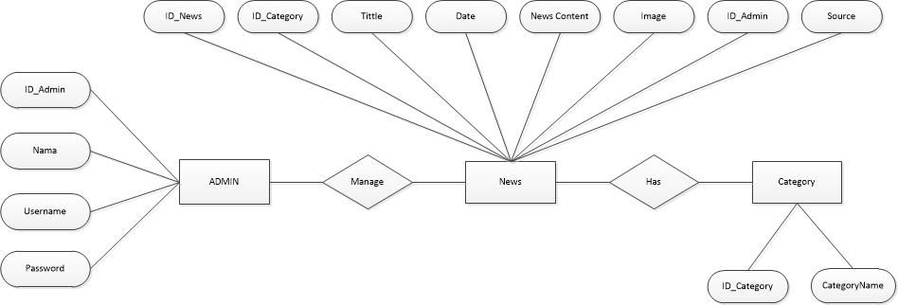

**ER DIAGRAM FOR SECONDZONE**

**\\**

**USE CASE DIAGRAM FOR SECONDZONE**

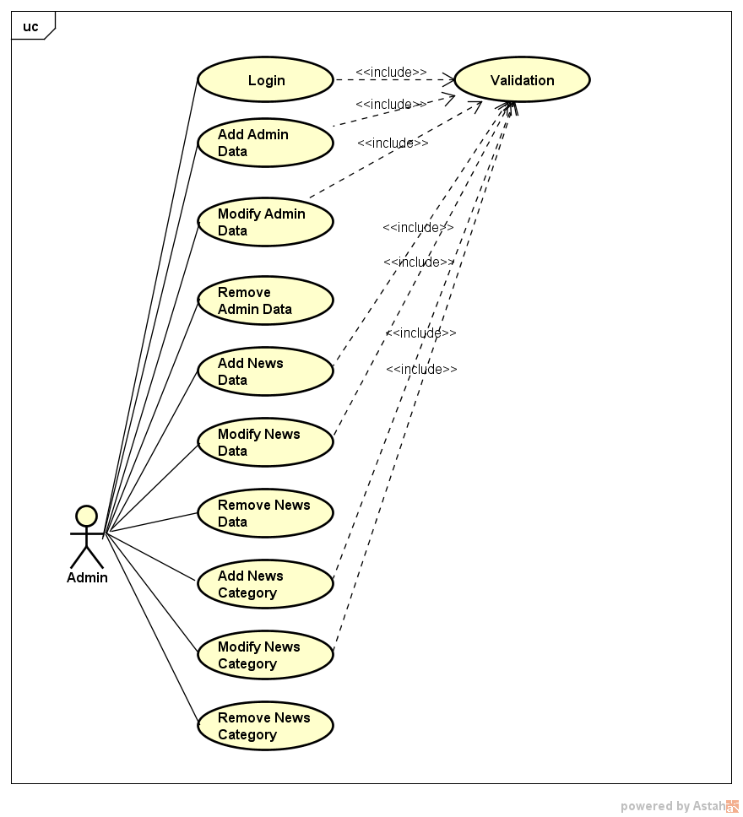

**ACTIVITY DIAGRAM FOR SECONDZONE**

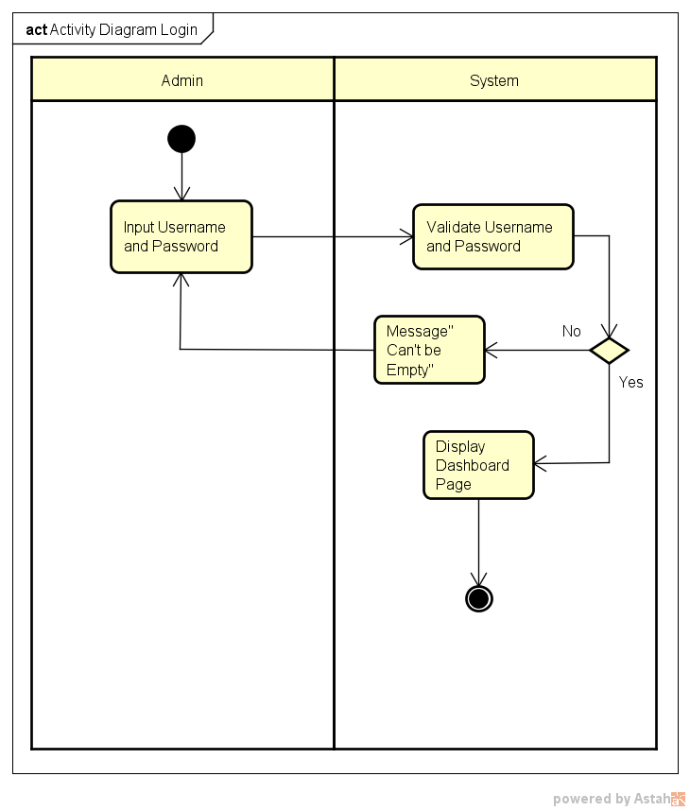

**\**

**ACTIVITY DIAGRAM FOR SECONDZONE**

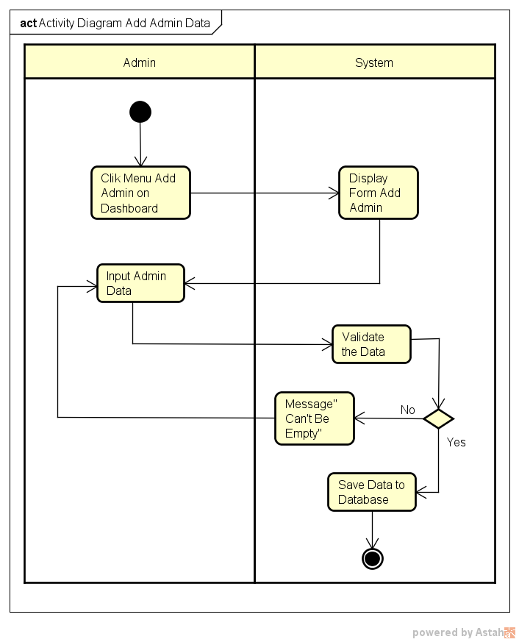

**ACTIVITY DIAGRAM FOR SECONDZONE**

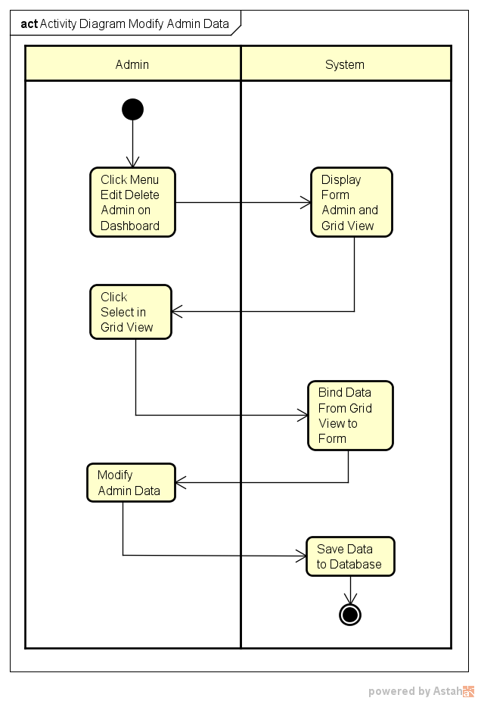

**ACTIVITY DIAGRAM FOR SECONDZONE**

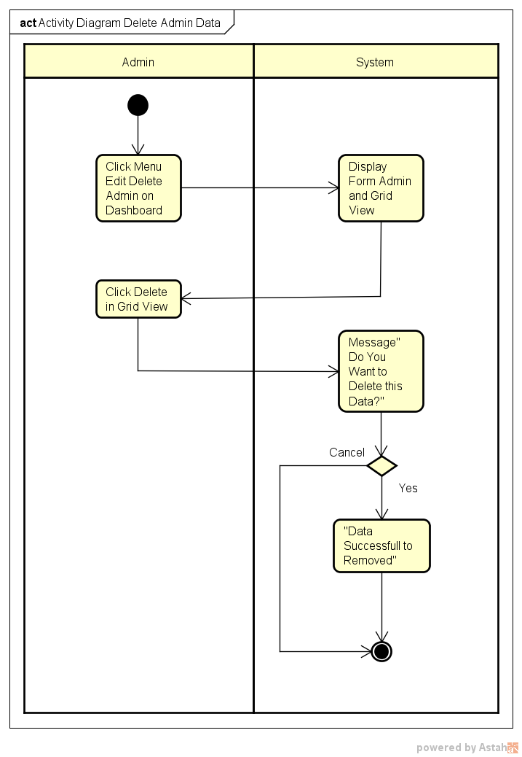

**ACTIVITY DIAGRAM FOR SECONDZONE**

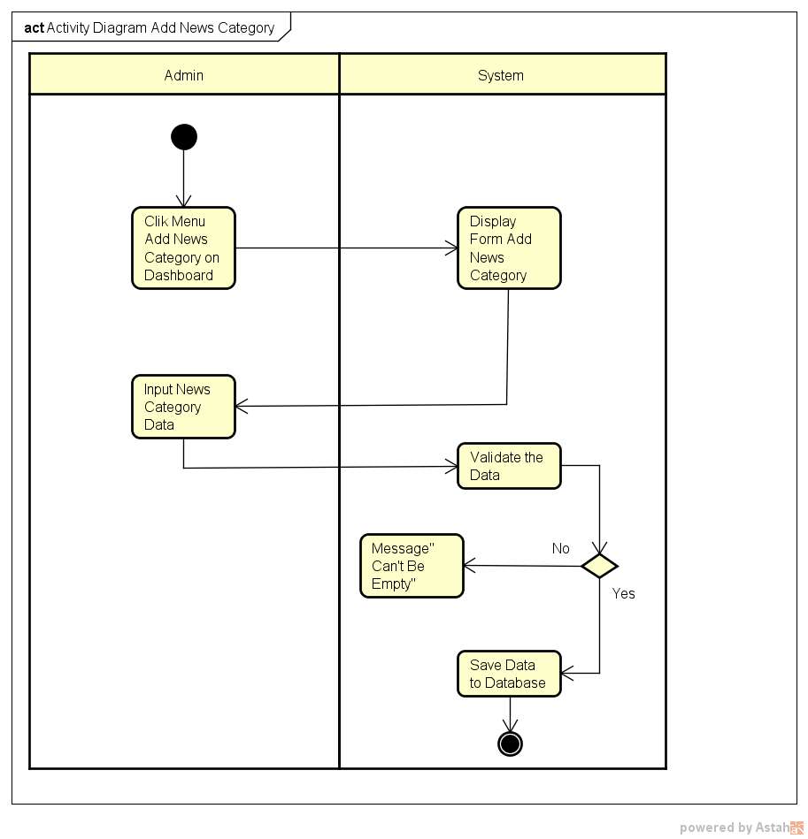

**ACTIVITY DIAGRAM FOR SECONDZONE**

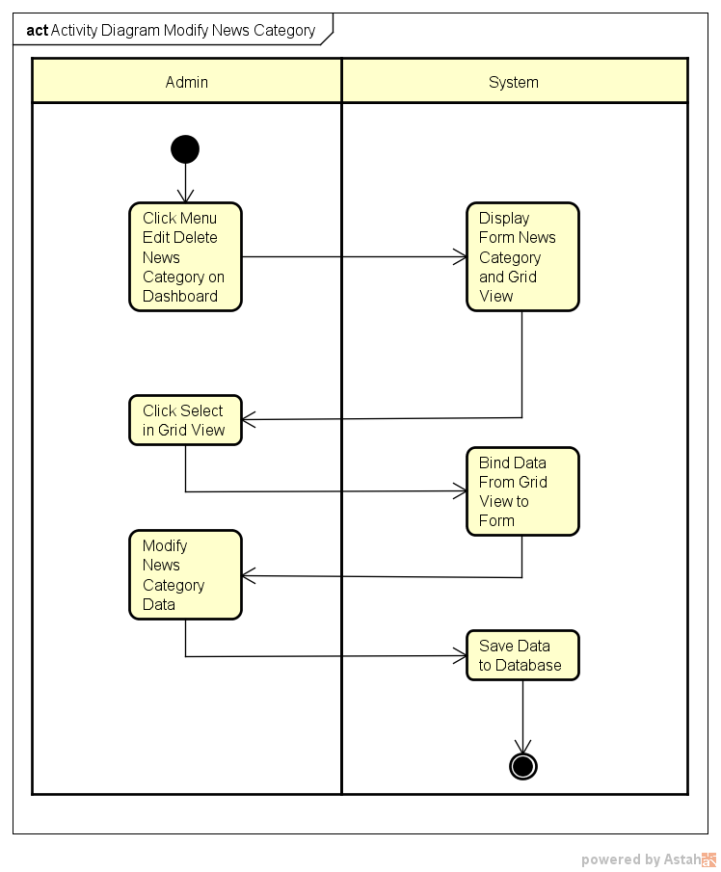

**ACTIVITY DIAGRAM FOR SECONDZONE**

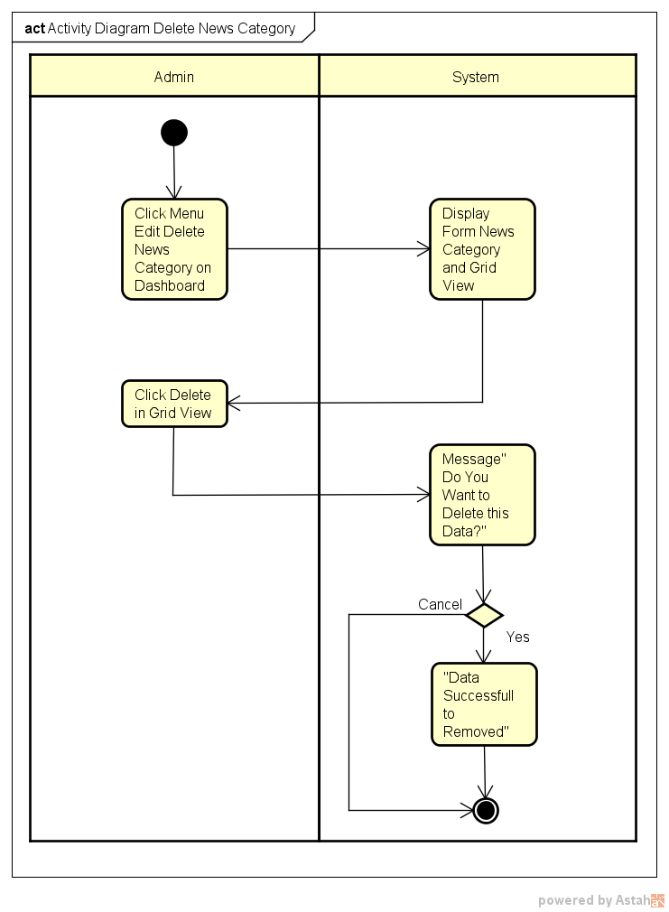

**ACTIVITY DIAGRAM FOR SECONDZONE**

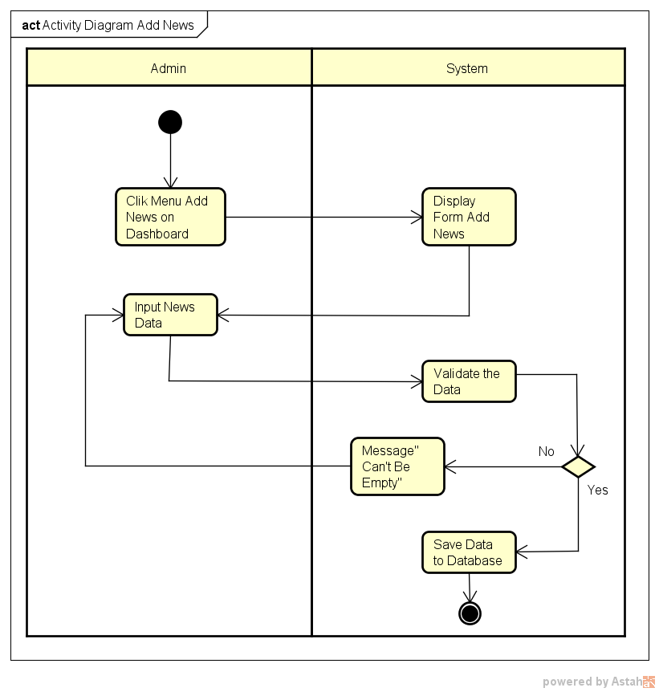

**ACTIVITY DIAGRAM FOR SECONDZONE**

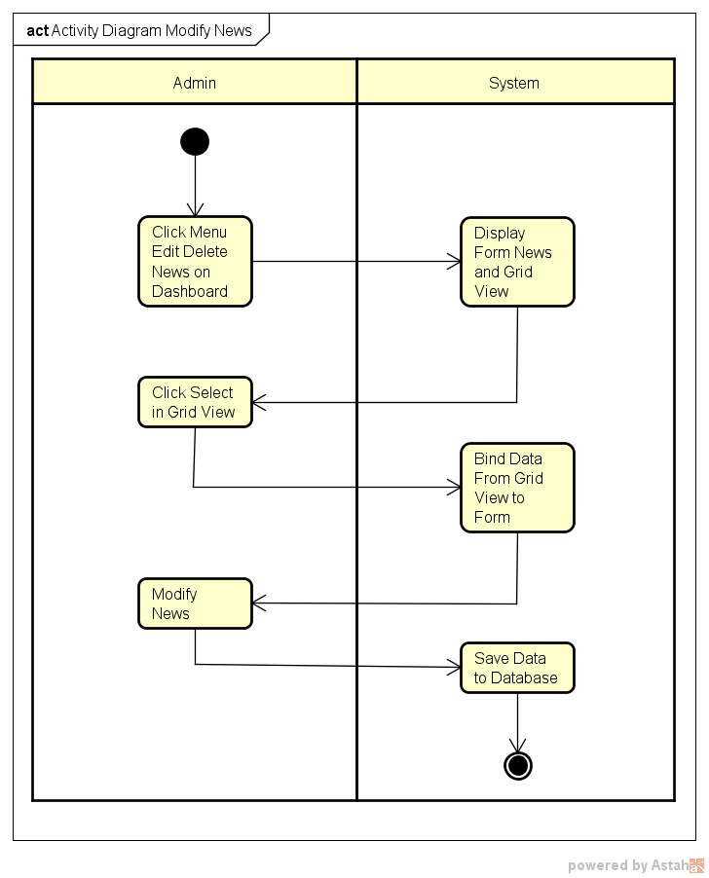

**ACTIVITY DIAGRAM FOR SECONDZONE**

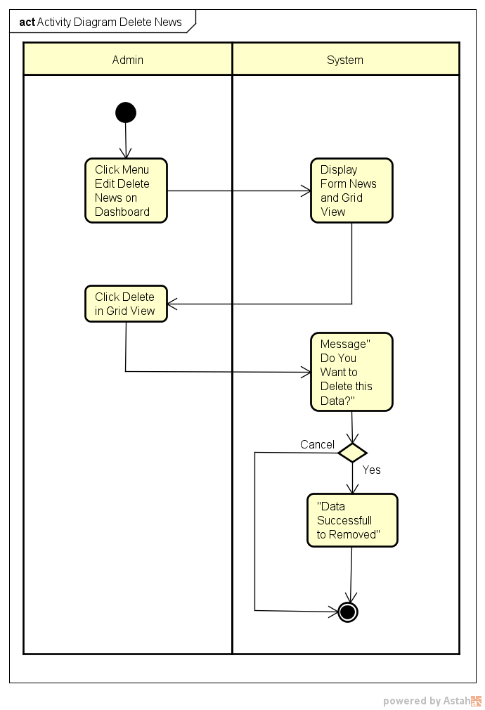

**SEQUENCE DIAGRAM FOR SECONDZONE**

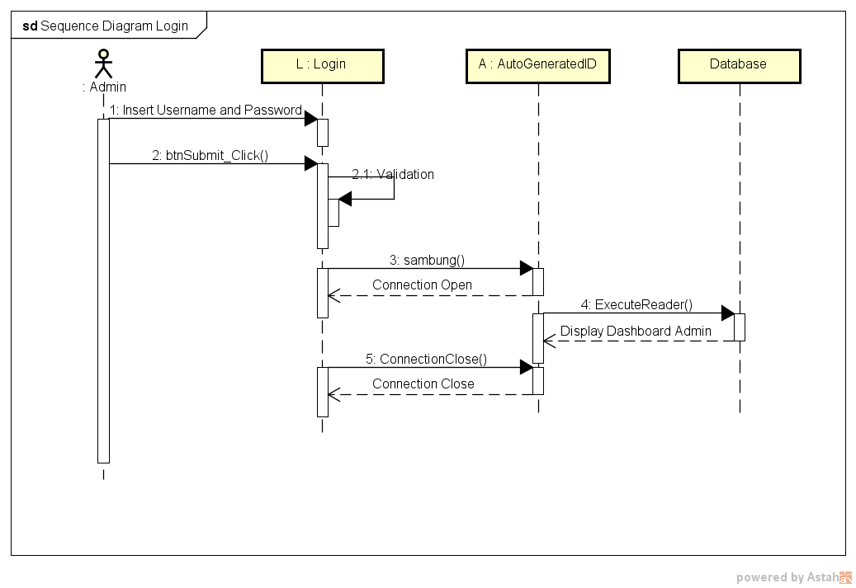

**SEQUENCE DIAGRAM FOR SECONDZONE**

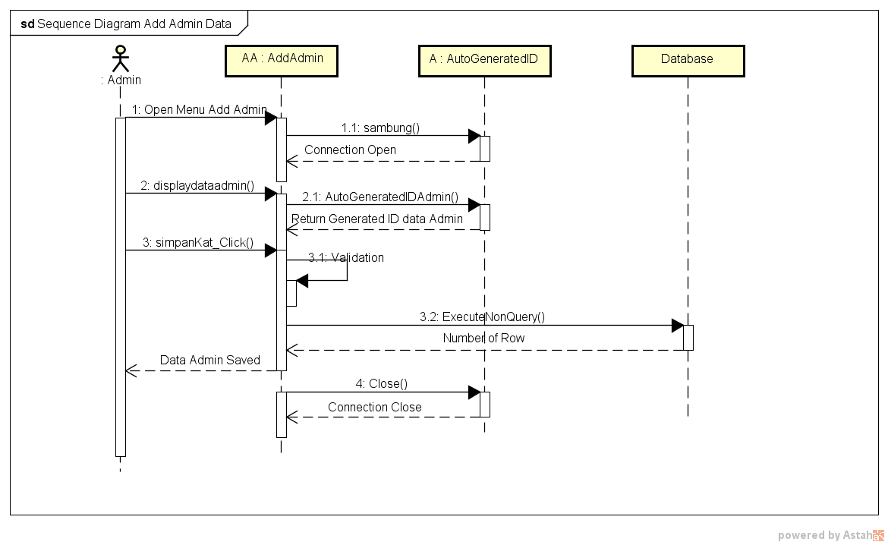

**SEQUENCE DIAGRAM FOR SECONDZONE**

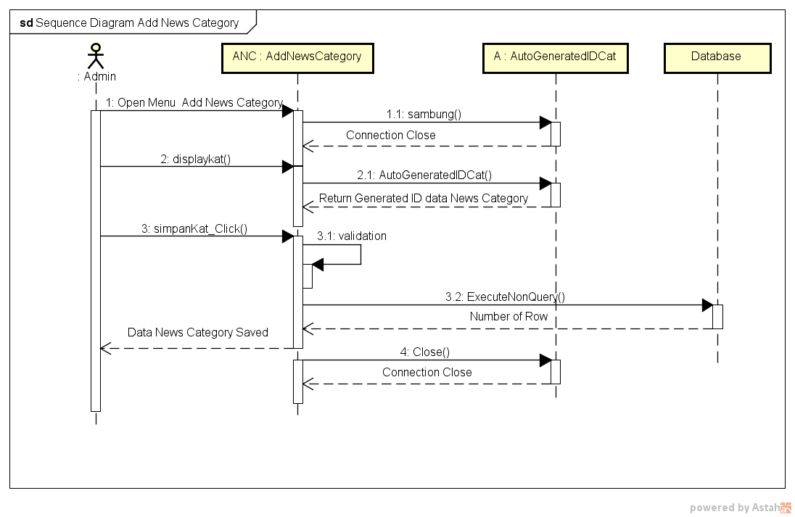

**SEQUENCE DIAGRAM FOR SECONDZONE**

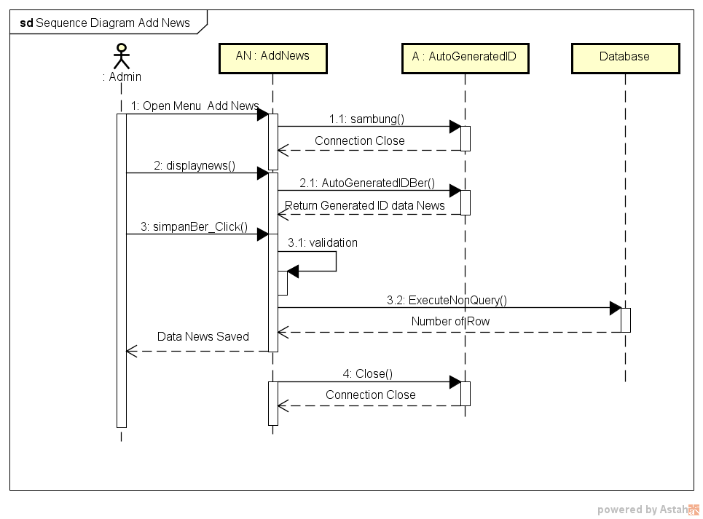

**SEQUENCE DIAGRAM FOR SECONDZONE**

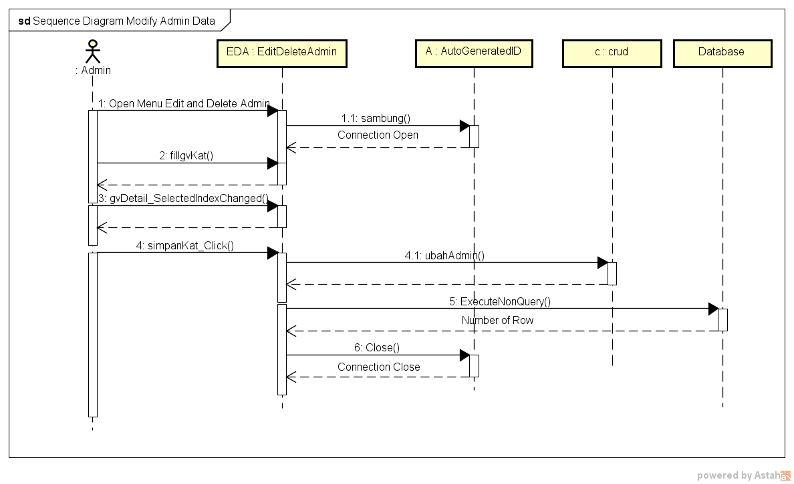

**SEQUENCE DIAGRAM FOR SECONDZONE**

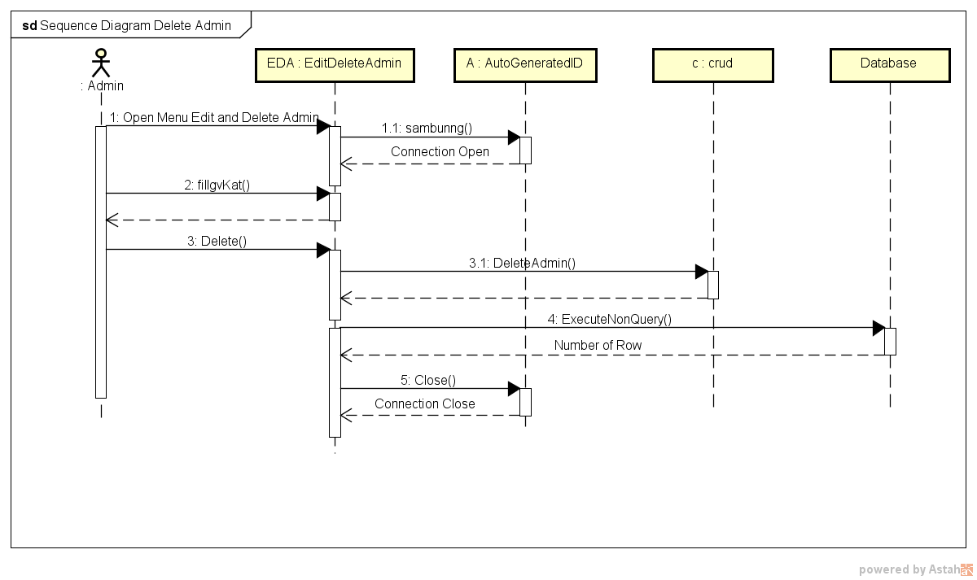

**SECONDZONE NEWS WEBSITE**

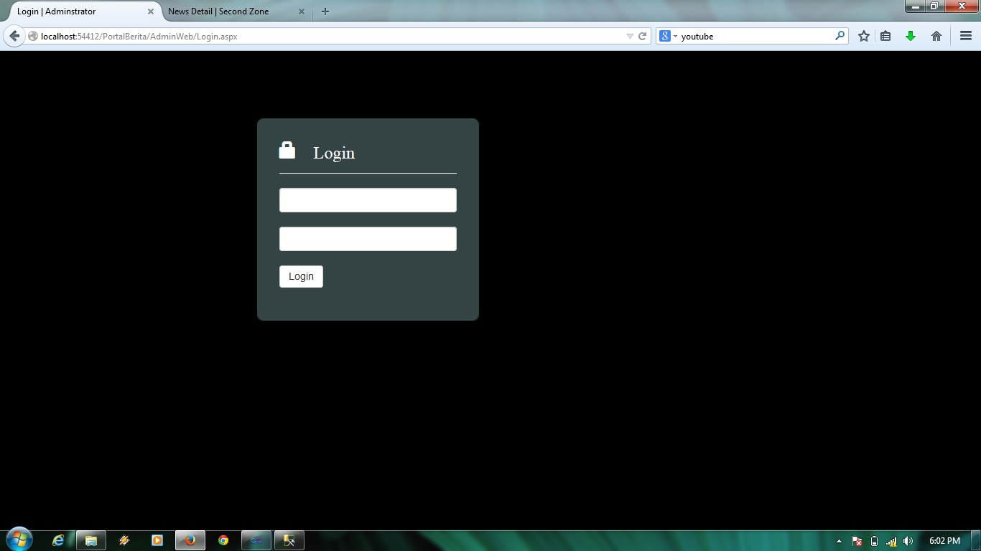

Login Admin Page

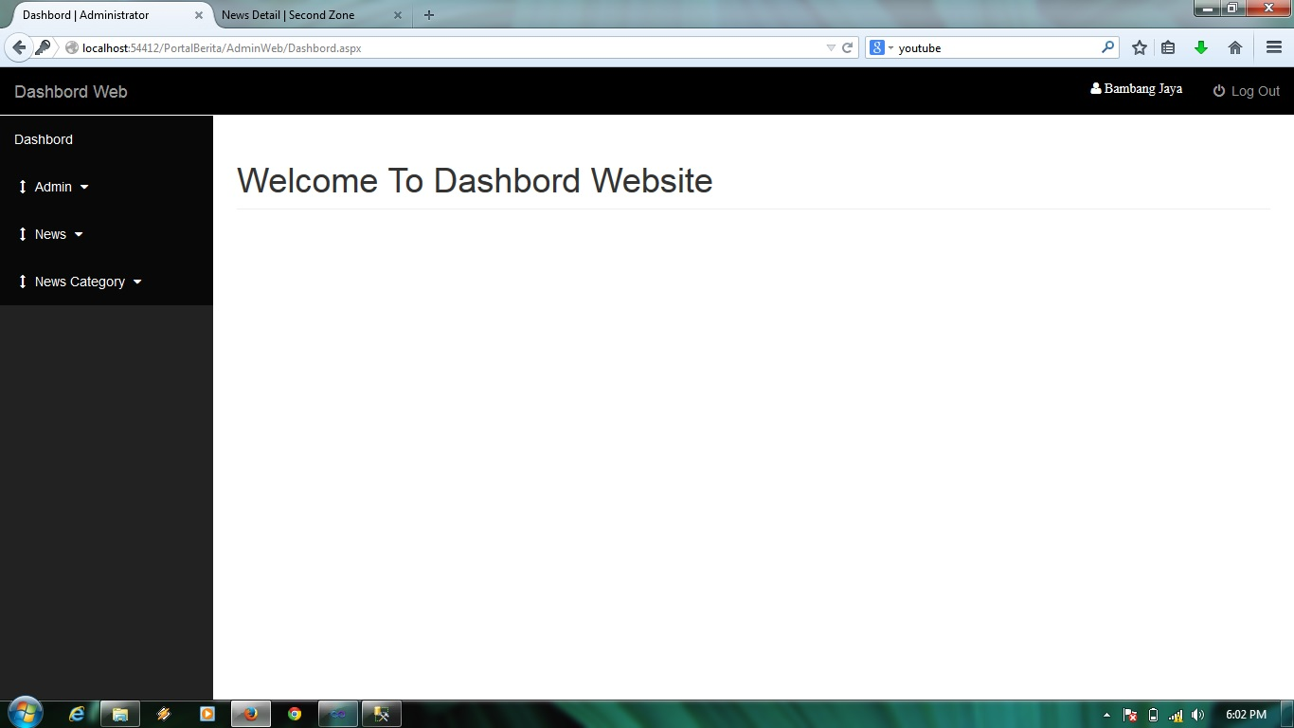

Dashboard Admin Page

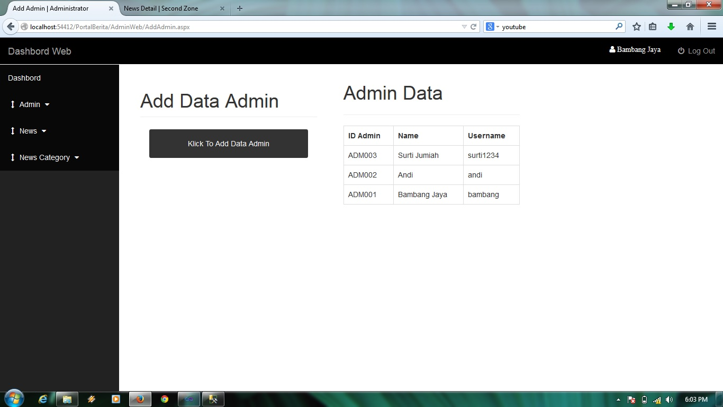

Add Admin Page

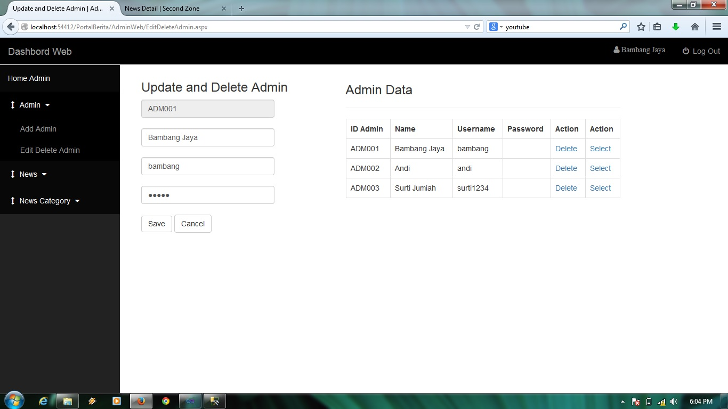

Update and Delete Admin Page

**SECONDZONE NEWS WEBSITE**

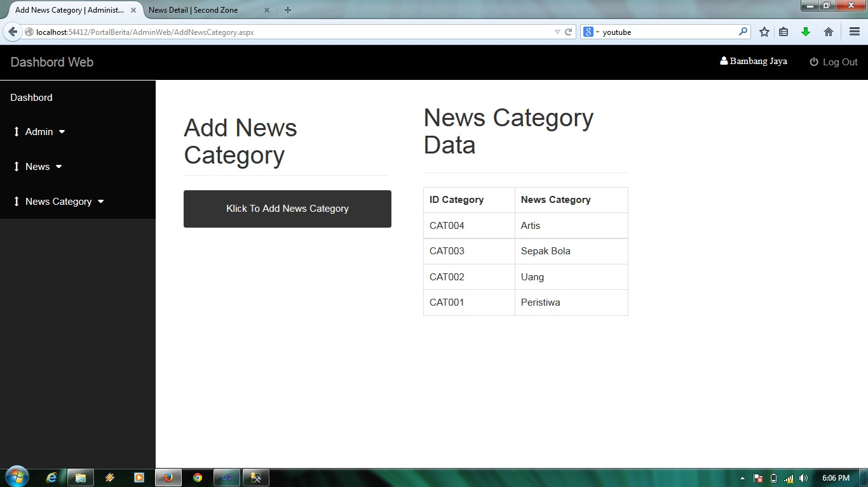

Add News Category Page

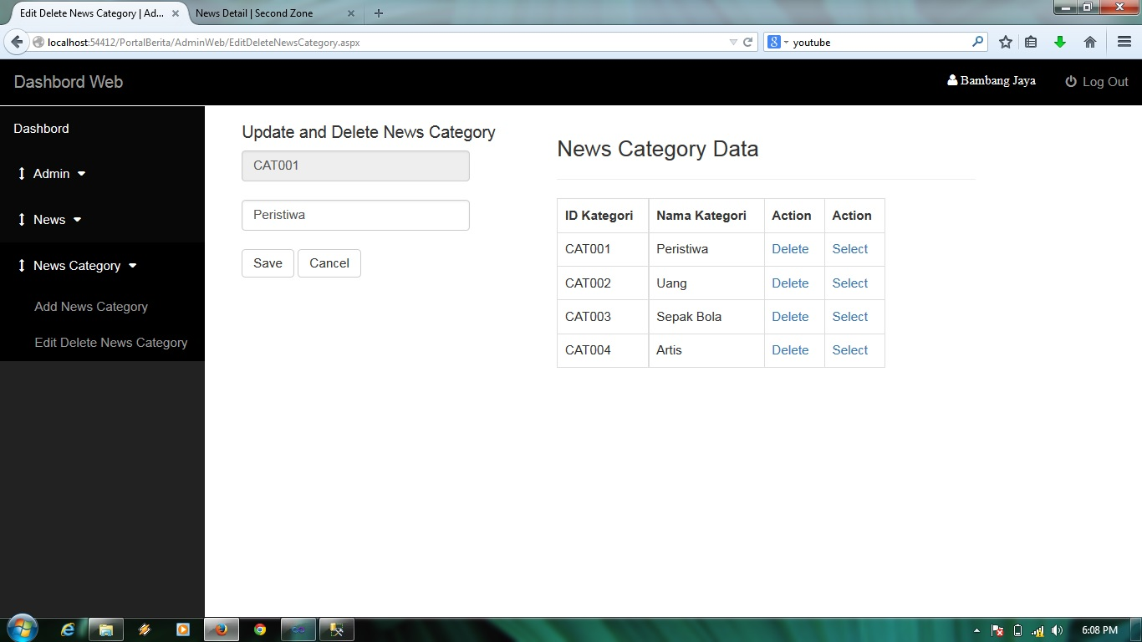

Update and Delete News Category Page

**SECONDZONE NEWS WEBSITE**

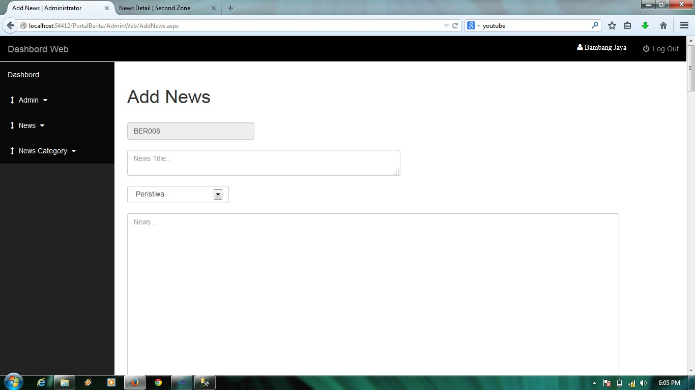

Add News Page

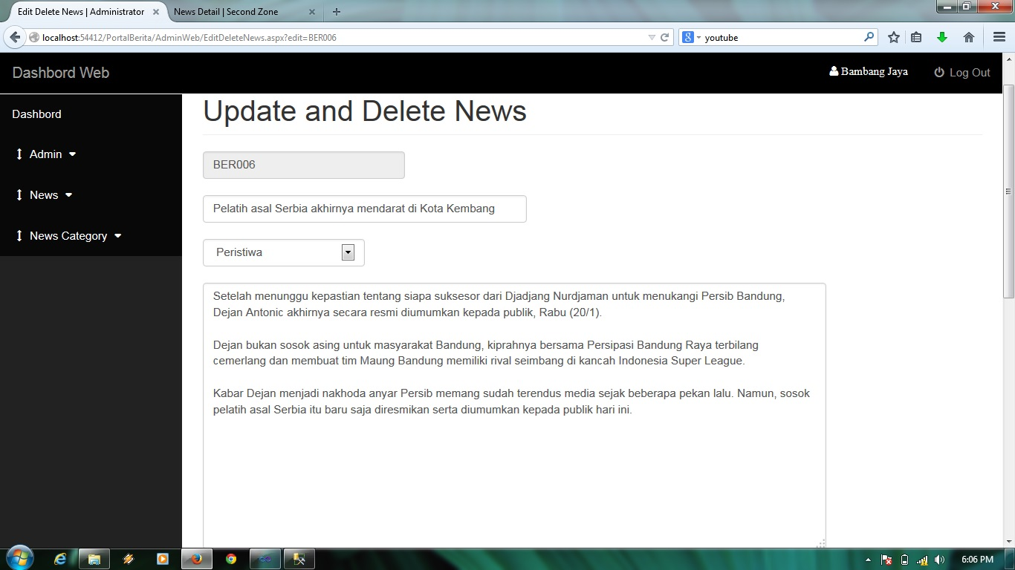

Update and Delete News Page

**SECONDZONE NEWS WEBSITE**

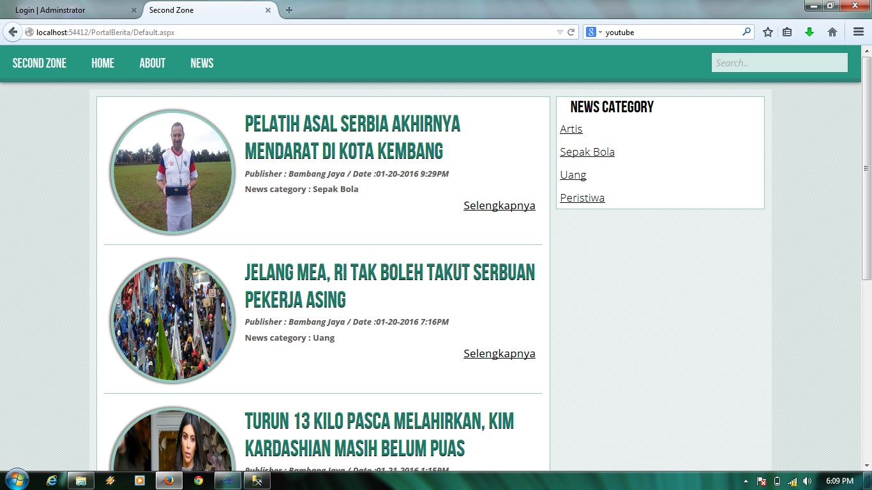

Home Page

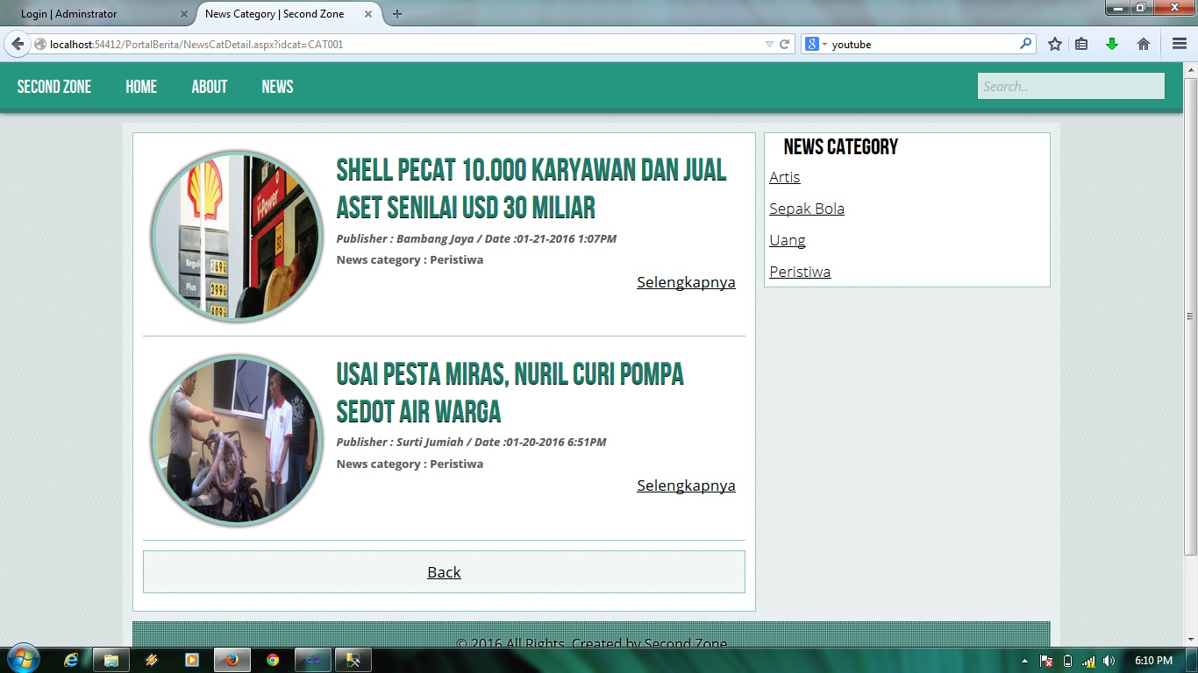

News based on Category Page

**SECONDZONE NEWS WEBSITE**

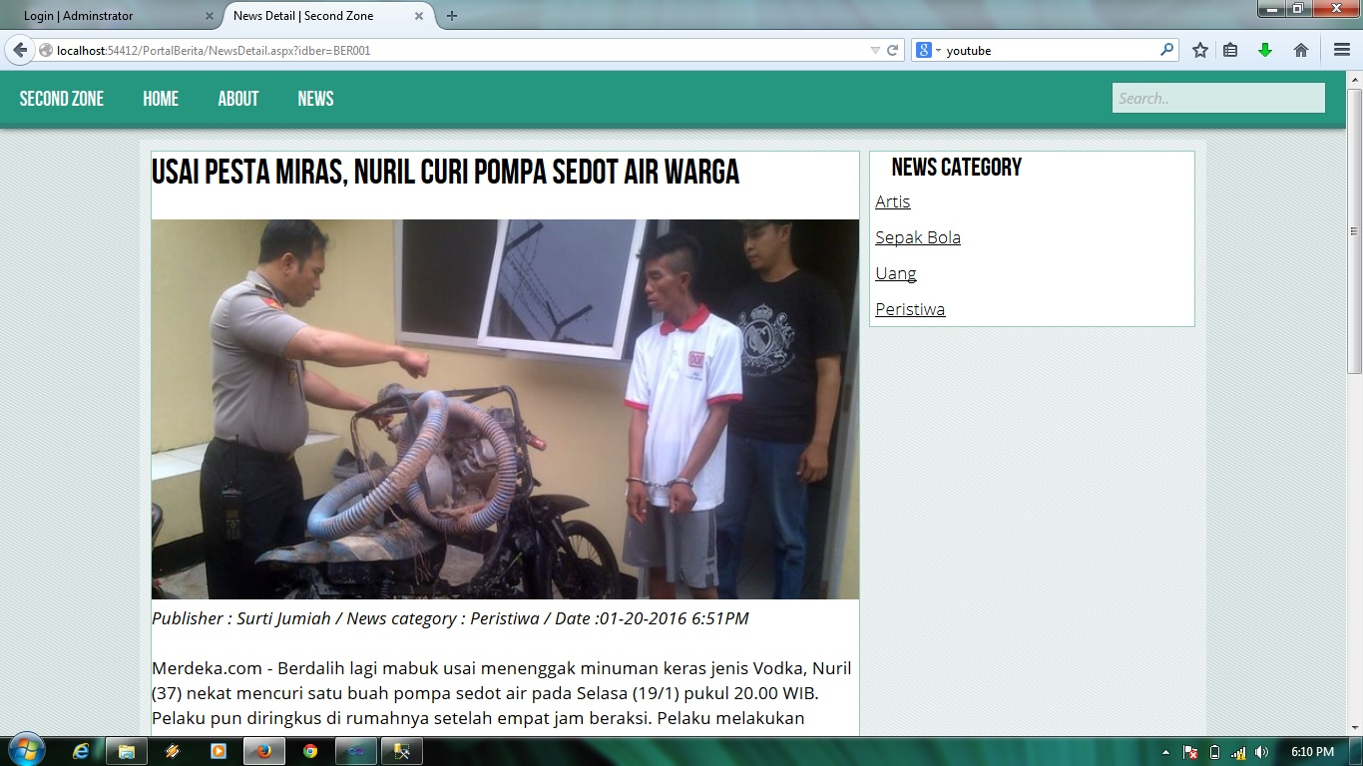

News Detail Page

**SECONDZONE NEWS WEBSITE**